Ricci Lam

A112992490

Professor Anderson

Physics 2BL/11 AM Section

July 13, 2016

**Lab 02 Write-Up**

Methods

Activity A: Tracking the Two-Ball Drop

None

Activity B: Cart Connected to a Mass on a Pulley

None

Data

Activity A: Tracking the Two-Ball Drop

* h = 2.5m ± 0.05m
* t1vert  = 0.508s t2vert = 1.193s Δt1 = t2vert – t1vert­ = 0.685s ± 0.016s = Δtvert
* t1horz = 0.466s t2horz = 1.201s Δt2 = t2horz – t1horz = 0.735 ± 0.016s = Δthorz

Horizontally Launched Ball:

Height (m) versus Time (sec)

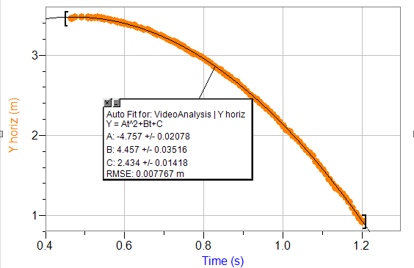

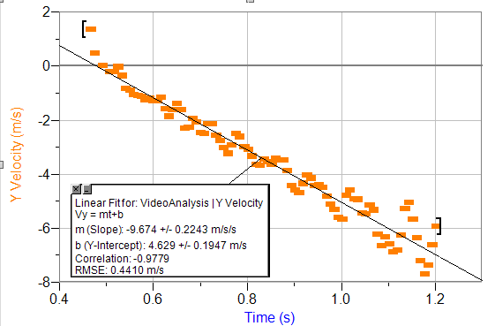Velocity (m/s) versus Time (sec)

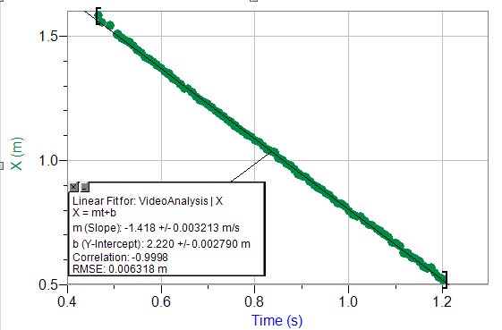Horizontal Position (m) Versus Time (sec)

Vertically Dropped Ball

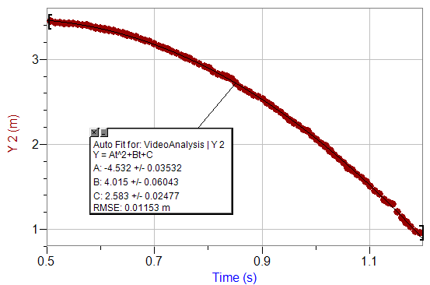Height (m) versus Time (sec)

Velocity (m/s) versus Time (sec)

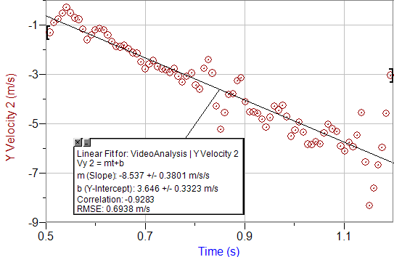

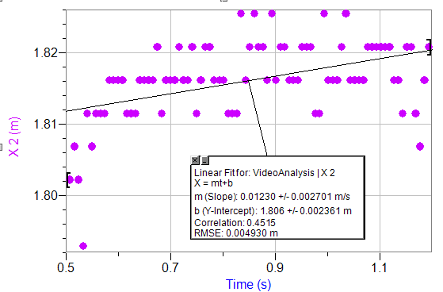 Horizontal Position (m) versus Time (sec)

Activity B: Cart Connected to a Mass on a Pulley

Mass of Cart: 501.7 ± 0.05 grams

Mass of Block 1: 510.9 ± 0.05 grams

Mass of Block 2: 510.9 ± 0.05 grams

Mass of Hanging Weight: 230.7 ± 0.05 grams

Mass of Increased Hanging Weight = 250.5 ± 0.05 g

Graphs from Logger Pro

B7

Position (m) versus Time (sec)

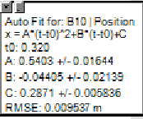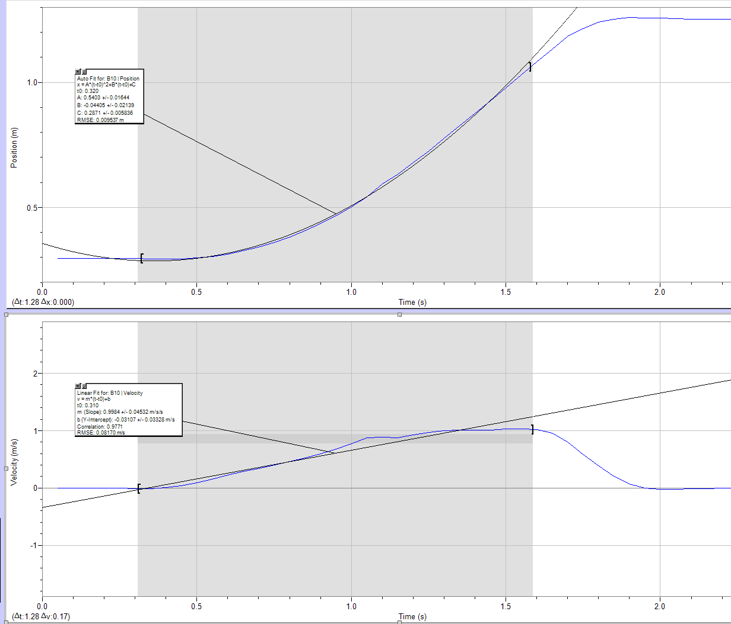

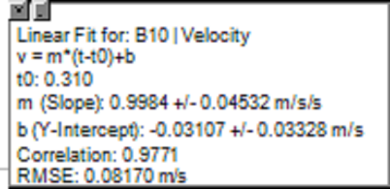Velocity (m/s) Versus Time (sec)

Acceleration (m/s2) versus Time (sec)

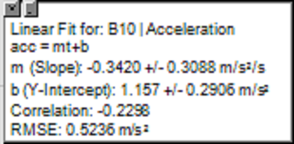

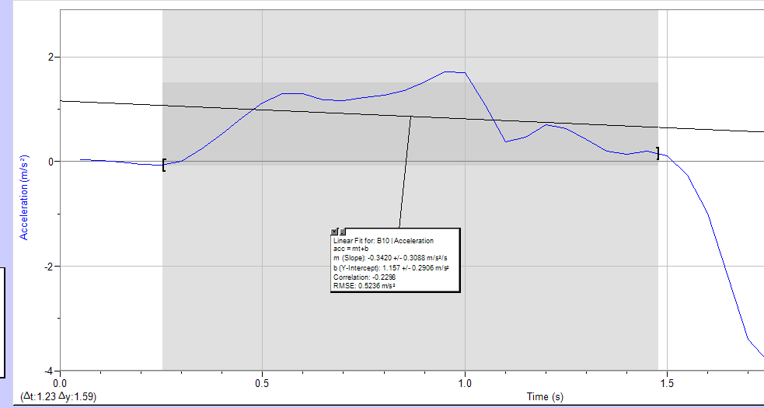

B11.

Position (m) versus Time (sec)

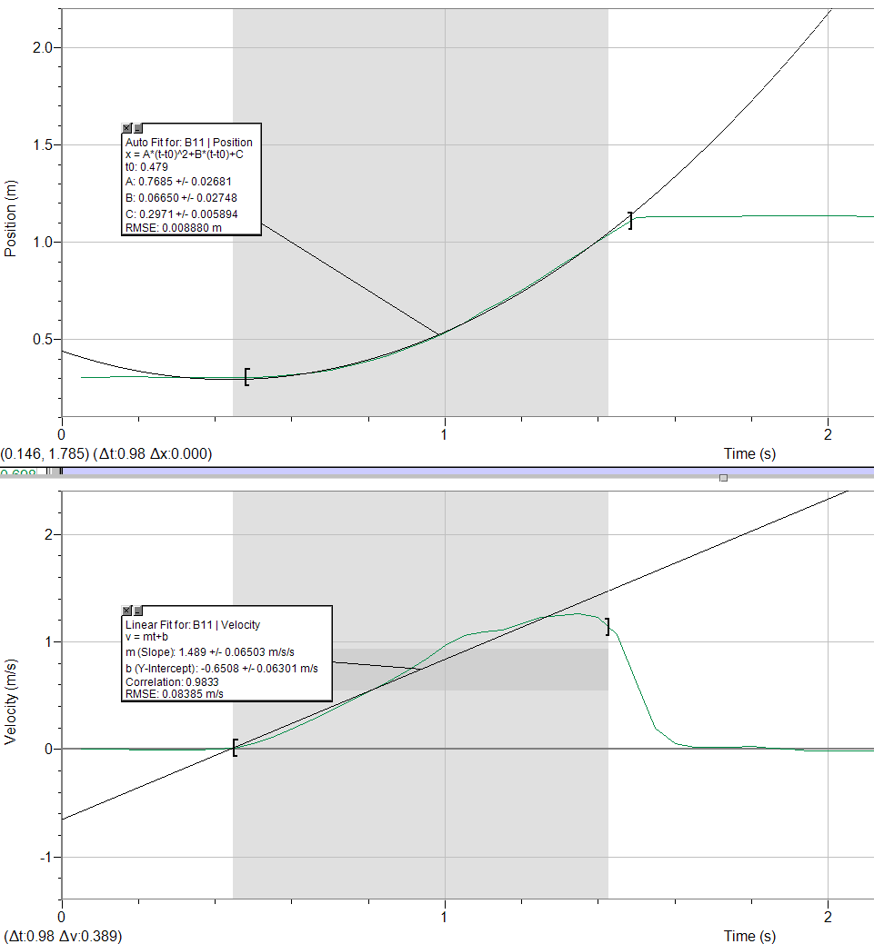

Velocity (m/s) versus Time (sec)

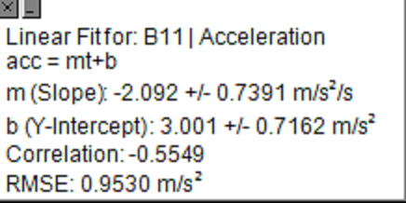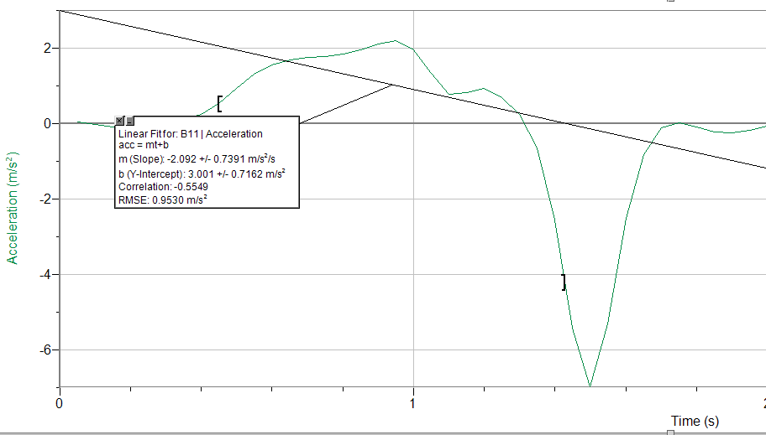Acceleration (m/s2) versus Time (sec)

B12.

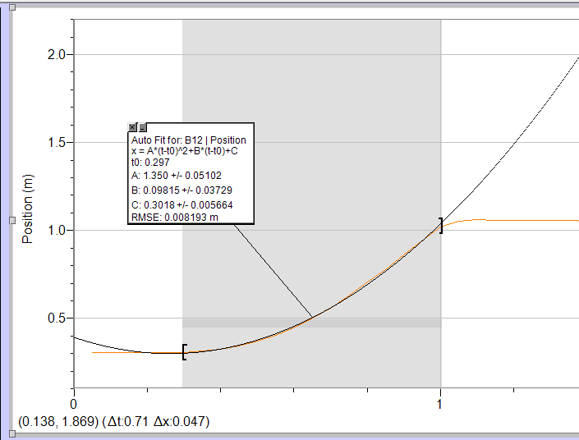 Position (m) Versus Time (sec)

Velocity (m/s) versus Time (sec)

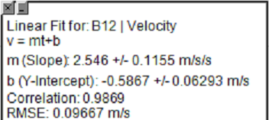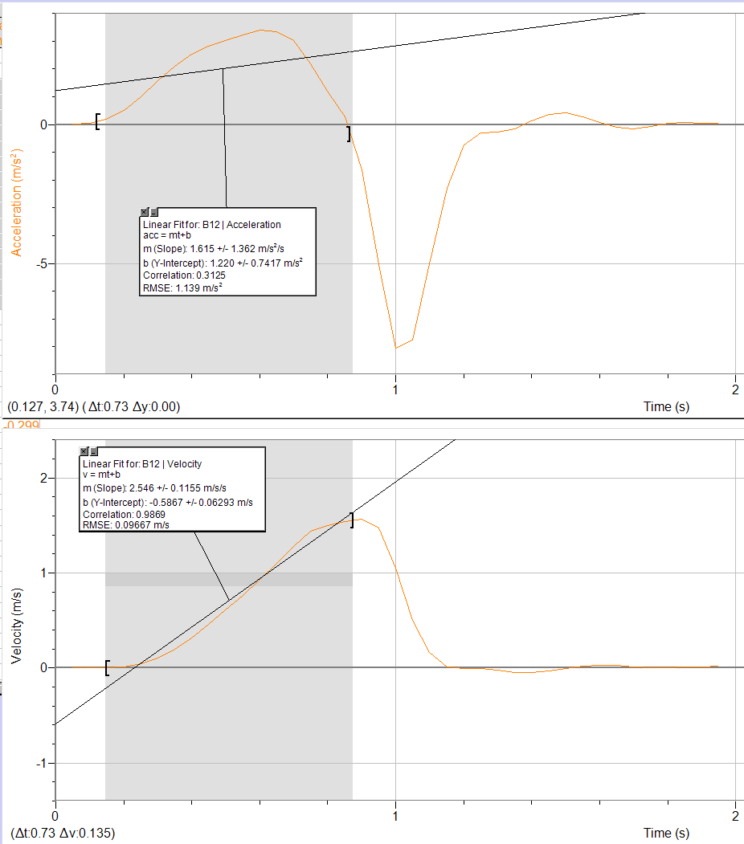

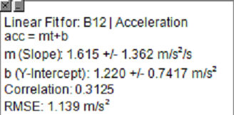 Acceleration (m/s2) versus Time (sec)

B13.

Position (m) versus Time (sec)

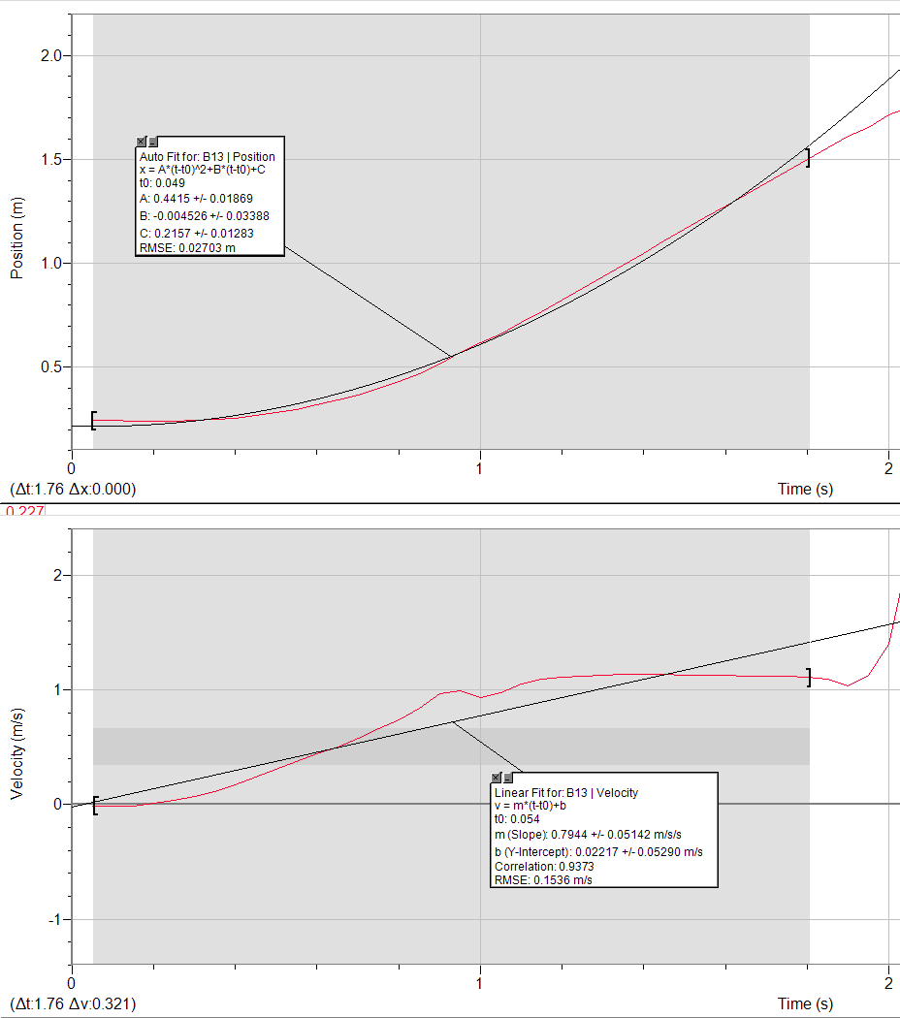

 Velocity (m/s) versus Time (sec)

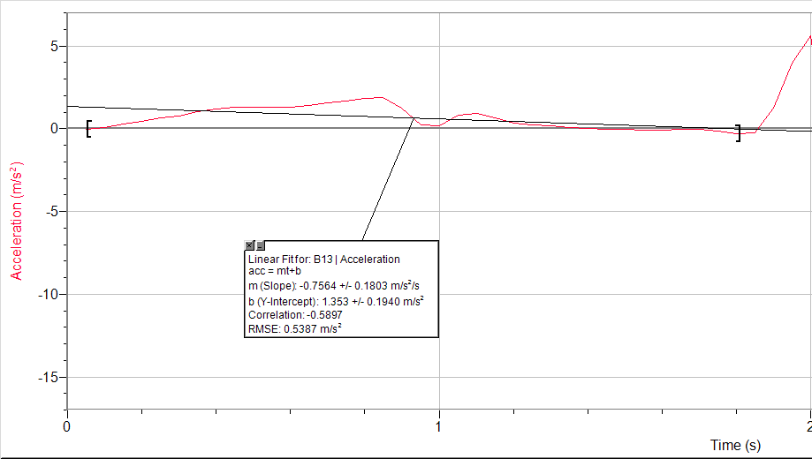 Acceleration (m/s2) versus Time (sec)

B14.

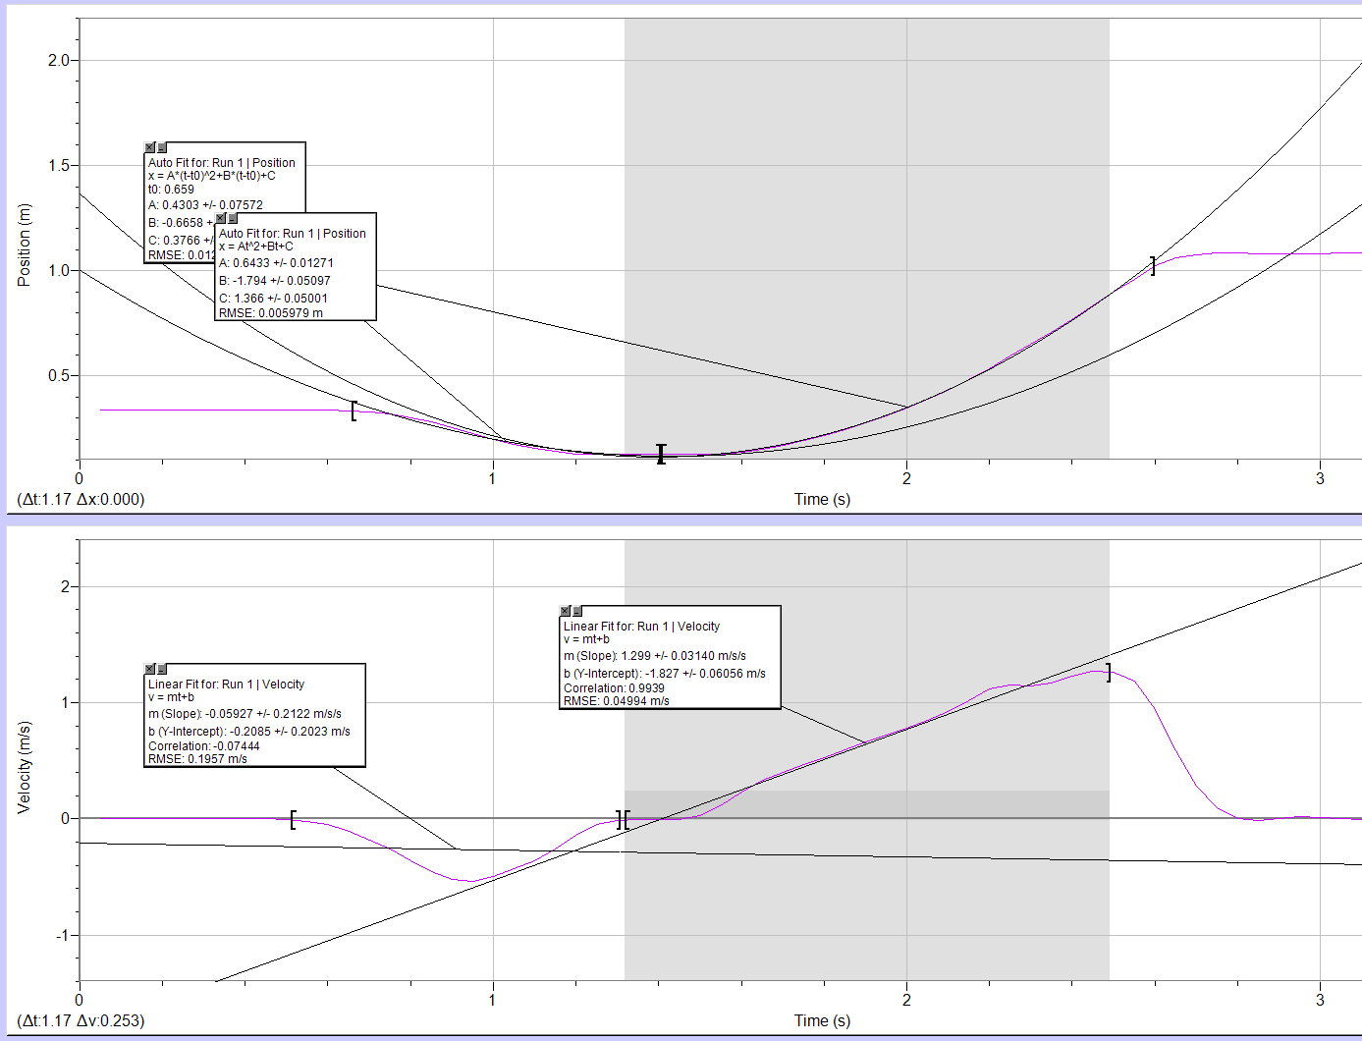 Position (m) versus Time (sec)

Velocity (m/s) versus Time (sec)



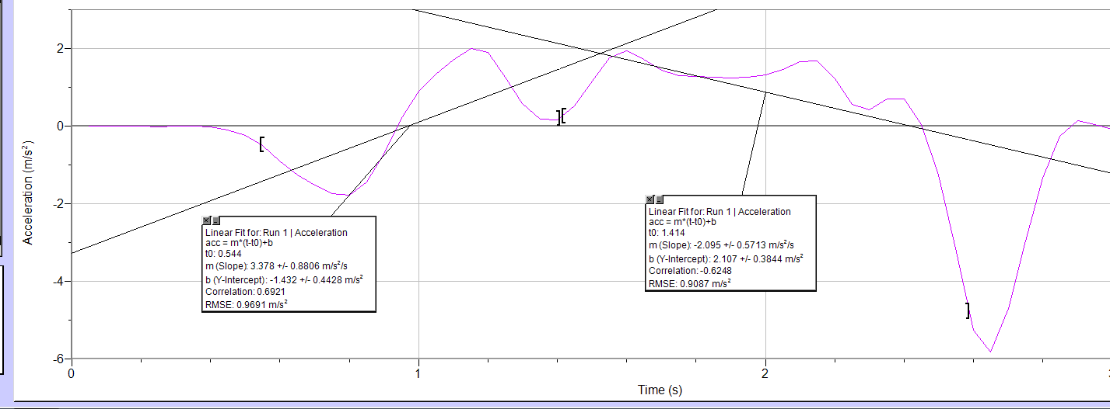Acceleration (m/s2) versus Time (sec)

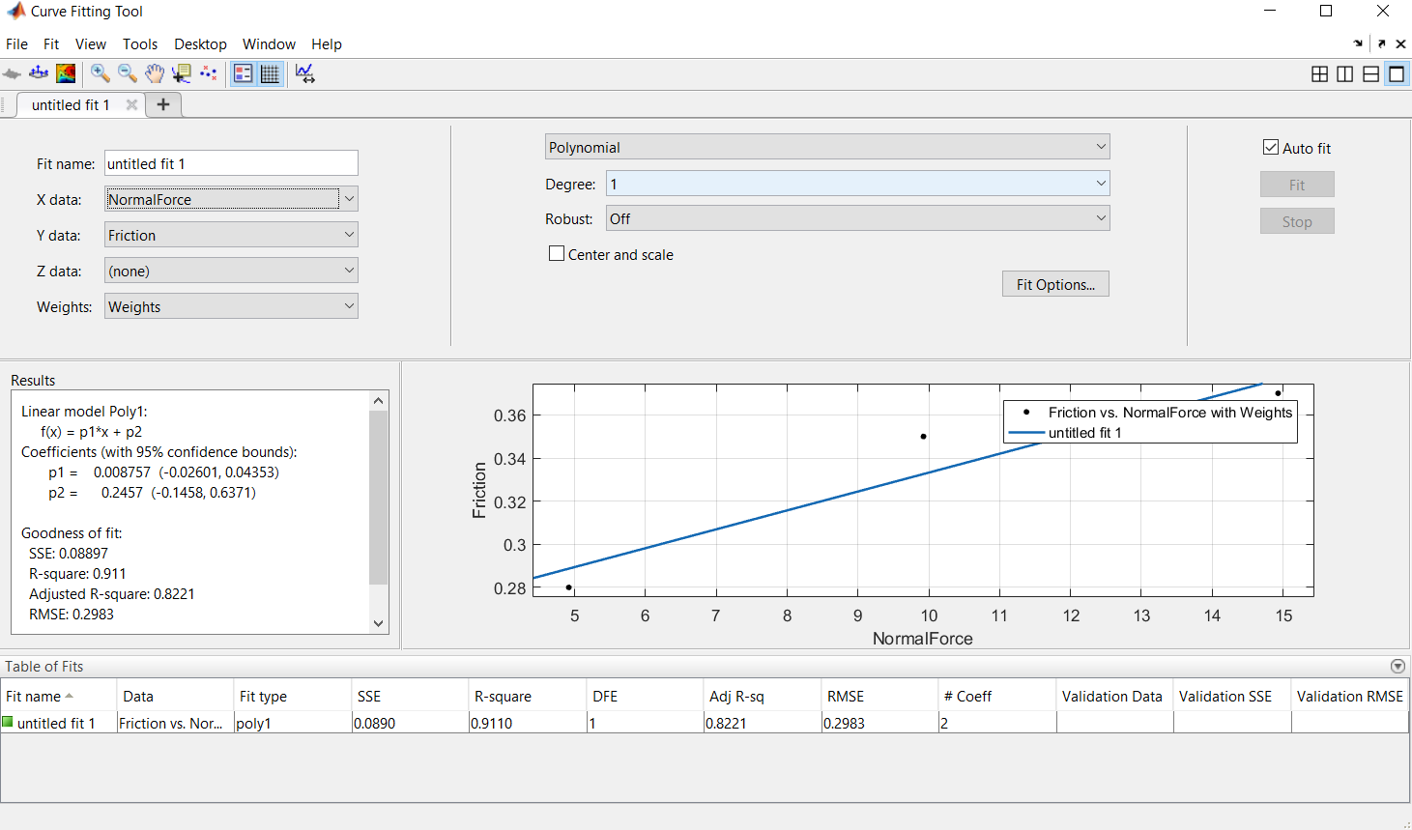Friction (N) versus Normal Force (N)

Results and Analysis

* Activity A: Tracking the Two-Ball Drop
  + The ‘A’ Value from both Quadratic Fits was used to calculate ‘g’.
  + The fits and their uncertainties were first multiplied by 2, because the formula for position with acceleration is ½A(t2)+B(t)+C. The obtained values are as follows:
    - Ay-horizontal­ = A1 = -9.514 ± 0.0416 m/s2
    - Ay-vertical = A2 = -9.289 ± 0.0706 m/s2
  + The averages of the two values of ‘g’ was found, along with an error propagation calculation to give δg.

$g= \frac{(A1+A2)}{2}$

$A1= \frac{dg}{dA1}= \frac{1}{2}$

$A2= \frac{dg}{dA2}= \frac{1}{2}$

$δg= \sqrt{{(\left(\frac{dg}{dA1}\right)\left(δA1\right))}^{2}+ {(\left(\frac{dg}{dA2}\right)\left(δA2\right))}^{2}}$

$-9.289 \frac{m}{s^{2}}= \frac{(-9.514 \frac{m}{s^{2}} +9.289 \frac{m}{s^{2}})}{2}$

$0.0579 \frac{m}{s^{2}}= \sqrt{{(\left(\frac{1}{2}\right)\left(0.0416 \frac{m}{s^{2}}\right))}^{2}+ {(\left(\frac{1}{2}\right)\left(0.0706 \frac{m}{s^{2}}\right))}^{2}}$
    - ­
    - g = -9.289 $\frac{m}{s^{2}}$ ± $0.0579 \frac{m}{s^{2}}$
  + $t= \sqrt{\frac{2h}{g}}$ = $0.714 s= \sqrt{\frac{2(2.5 m)}{9.8}}$
 $\frac{dt}{dh}= \frac{\sqrt{\frac{2}{g}}}{2\sqrt{h}}$

 $δt= \sqrt{{(\left(\frac{dt}{dh}\right)\left(δh\right))}^{2}}$ + = $0.019s= \sqrt{{(\left(\frac{\sqrt{\frac{2}{9.8 \frac{m}{s^{2}}}}}{2\sqrt{2.5 m}}\right)\left(0.05 m\right))}^{2}}$
  + **tcalculated = 0.714 ± 0.142s**
  + The calculated value of time matches the actual time for the ball that was launched horizontally, and if one were to compare the values and the uncertainties, the person would notice that there is overlap in the possible error bounds, meaning that the experimental value may very well be very close to the actual expected time. The calculated time was very far from the other value of Δt, indicating that there are other parts, such as the human factor, that introduced error to the collection of data.
  + $v=gt$ = $-6.997 \frac{m}{s}=(-9.8 \frac{m}{s^{2}})(0.714 s)$
 $δv=g\left(δt\right)=0.186 \frac{m}{s^{2}}= (9.8 \frac{m}{s^{2}})(0.019 s)$

   - **Vcalculated = -6.997 ± 0.186 (m/s)**
    - Error calculation is simple multiplication for propagation
  + Calculations to obtain the best value of vertical velocity from the experiment will be taken from the best fit graph with the error propagated

 $vhorz=A1\left(t2horz\right)+B1= -6.989 \frac{m}{s}=\left(-9.674 \frac{m}{s^{2}}\right)\left(1.201s\right)+4.629 \frac{m}{s}$

 $\frac{dvhorz}{dA1}=t2horz$ $\frac{dvhorz}{dt2horz}=A1$ $\frac{dvhorz}{dB1}=1$

$δvhorz= \sqrt{{(\left(\frac{dvhorz}{dA1}\right)\left(δA1\right))}^{2}+{(\left(\frac{dvhorz}{dt2horz}\right)\left(δthorz\right))}^{2}+{(\left(\frac{dvhorz}{dB1}\right)\left(δB1\right))}^{2}}$

$δvhorz= \sqrt{{(\left(t2horz\right)\left(δA1\right))}^{2}+{(\left(A1\right)\left(δthorz\right))}^{2}+{(\left(1\right)\left(δB1\right))}^{2}}$

$0.341 \frac{m}{s}= \sqrt{{(\left(1.201 s\right)\left(0.2243 \frac{m}{s^{2}}\right))}^{2}+{(\left(-9.674 \frac{m}{s^{2}}\right)\left(0.008s\right))}^{2}+{(\left(1 \frac{m}{s}\right)\left(0.1947 \frac{m}{s}\right))}^{2}}$

- **Vhorz = -6.989 ± 0.341 m/s**
 $vvert=A2\left(t2vert\right)+B2= -6.538 \frac{m}{s}=\left(-8.537 \frac{m}{s^{2}}\right)\left(1.193s\right)+3.646 \frac{m}{s}$

 $\frac{dvvert}{dA2}=t2vert$ $\frac{dvvert}{dt2vert}=A2$ $\frac{dvvert}{dB}=1$

$δvvert= \sqrt{{(\left(\frac{dvvert}{dA2}\right)\left(δA2\right))}^{2}+{(\left(\frac{dvvert}{dt2vert}\right)\left(δtvert\right))}^{2}+{(\left(\frac{dvvert}{dB2}\right)\left(δB2\right))}^{2}}$

$δvvert= \sqrt{{(\left(t2vert\right)\left(δA2\right))}^{2}+{(\left(A2\right)\left(δtvert\right))}^{2}+{(\left(1\right)\left(δB2\right))}^{2}}$

$0.566 \frac{m}{s}= \sqrt{{(\left(1.193 s\right)\left(0.3801 \frac{m}{s^{2}}\right))}^{2}+{(\left(-8.537 \frac{m}{s^{2}}\right)\left(0.008s\right))}^{2}+{(\left(1 \frac{m}{s}\right)\left(0.3323 \frac{m}{s}\right))}^{2}}$

- **Vvert­ = -6.538 ± 0.556 m/s**
* Vcalculated = -6.997 ± 0.186 (m/s) Vhorz = -6.989 ± 0.341 m/s Vvert­ = -6.538 ± 0.556 m/s
  + As is evident, the calculated value of velocity when the balls hit the ground is very similar to the experimental results and is within the bounds of error, as all three values have overlapping fields of error. The calculation is in line with the experimental data.
* Activity B: Cart Connected to a Mass on a Pulley
  + Calculation for B7
  + mcart = 1.5325 ± 0.00015 kg
  + mweight = 0.2307 ± 0.00005 kg
  + a = 2(AB7) = 2(0.5403 ± 0.01644 (m/s2)) = 1.0806 ± 0.03288 (m/s2)

* **Fnormal = 14.9303 ± 0.00147 N**
* *there is no need to the error propagation formula here because there is only one variable being multiplied, logically, the uncertainty will be propagated by multiplication




$F_{friction}=m_{weight}g-m_{weight}a-m_{cart}a$

$0.3640 N=(0.2307 kg)(9.8 \frac{m}{s^{2}})-(0.2307 kg)(1.0806 \frac{m}{s^{2}})-(1.5235 kg)(1.0806 \frac{m}{s^{2}})$

$δF_{friction}= \sqrt{{(\left(\frac{dF}{dm_{weight}}\right)\left(δm_{weight}\right))}^{2}+{(\left(\frac{dF}{da}\right)\left(δa\right))}^{2}+{(\left(\frac{dF}{dm_{cart}}\right)\left(δm_{cart}\right))}^{2}}$

$\frac{dF}{dm_{weight}}=g-a$ $\frac{dF}{da}= -m_{weight}-m_{cart}$ $\frac{dF}{dm_{cart}}= -a$

$δF_{friction}= \sqrt{{(\left(g-a\right)\left(δm_{weight}\right))}^{2}+{(\left(-m_{weight}-m_{cart}\right)\left(δa\right))}^{2}+{(\left(-a\right)\left(δm_{cart}\right))}^{2}}$

$0.0580 N= \sqrt{{(\left(9.8 \frac{m}{s^{2}}-1.0806 \frac{m}{s^{2}}\right)\left(0.00005\right))}^{2}+{(\left(-0.2307 kg-1.5325 kg\right)\left(0.03288 \frac{m}{s^{2}}\right))}^{2}+{(\left(-1.0806 \frac{m}{s^{2}}\right)\left(0.00015 kg\right))}^{2}}$

* **Ffriction = 0.3640 ± 0.0580 N**
  + Calculation for B11
  + mcart = 1.0126 ± 0.0001 kg
  + mweight = 0.2307 ± 0.00005 kg
  + a = 2(AB11) = 2(0.7685 ± 0.0268 (m/s2)) = 1.5370 ± 0.0536 (m/s2)

* **Fnormal = 9.9235 ± 0.00098 N**
$F_{friction}=m_{weight}g-m_{weight}a-m_{cart}a$

$0.3499 N=(0.2307 kg)(9.8 \frac{m}{s^{2}})-(0.2307 kg)(1.5370 \frac{m}{s^{2}})-(1.0126 kg)(1.5370 \frac{m}{s^{2}})$

$0.0666 N= \sqrt{{(\left(9.8 \frac{m}{s^{2}}-1.5370 \frac{m}{s^{2}}\right)\left(0.00005\right))}^{2}+{(\left(-0.2307 kg-1.0126 kg\right)\left(0.0536 \frac{m}{s^{2}}\right))}^{2}+{(\left(-1.5370 \frac{m}{s^{2}}\right)\left(0.0001 kg\right))}^{2}}$

* **Ffriction = 0.3499 ± 0.0666 N**
  + Calculation for B12
  + mcart = 0.5017 ± 0.00005 kg
  + mweight = 0.2307 ± 0.00005 kg
  + a = 2(AB11) = 2(1.350 ± 0.05102 (m/s2)) = 2.700 ± 0.10204 (m/s2)

* **Fnormal = 4.9166 ± 0.00049 N**
$F_{friction}=m_{weight}g-m_{weight}a-m_{cart}a$

$0.2834 N=(0.2307 kg)(9.8 \frac{m}{s^{2}})-(0.2307 kg)(2.700 \frac{m}{s^{2}})-(0.5017 kg)(2.700 \frac{m}{s^{2}})$

$0.0747 N= \sqrt{{(\left(9.8 \frac{m}{s^{2}}-2.700 \frac{m}{s^{2}}\right)\left(0.00005\right))}^{2}+{(\left(-0.2307 kg-0.5017 kg\right)\left(0.10204 \frac{m}{s^{2}}\right))}^{2}+{(\left(-2.700 \frac{m}{s^{2}}\right)\left(0.00005 kg\right))}^{2}}$

* **Ffriction = 0.2834 ± 0.0747 N**

Conceptual Questions

* Activity A: Tracking the Two-Ball Drop
  + t1horz = 0.466s t2horz = 1.201s Δt2 = t2horz – t1horz = 0.735 ± 0.016s = Δthorz
  + t1vert  = 0.508s t2vert = 1.193s Δt1 = t2vert – t1vert­ = 0.685s ± 0.016s = Δtvert
  + The uncertainty of time spent in the air is simply the original uncertainty provided by Logger Pro and then doubled. The original uncertainty only needs to be doubled because the two values are from the same reading. Meaning that the farthest the actual value can be from the best value is double of the uncertainty of the original values.
  + This calculation fits quite well with the experimental values, falling right in the middle of the two experimental results. The fields of uncertainty on all three values have some overlap, indicating that there is possibility that the experimental values are the same as the calculated accepted value
    - $t= \sqrt{\frac{2h}{g}}$ = $0.714 s= \sqrt{\frac{2(2.5 m)}{9.8}}$
 $\frac{dt}{dh}= \frac{\sqrt{\frac{2}{g}}}{2\sqrt{h}}$

 $δt= \sqrt{{(\left(\frac{dt}{dh}\right)\left(δh\right))}^{2}}$  - = $0.019s= \sqrt{{(\left(\frac{\sqrt{\frac{2}{9.8 \frac{m}{s^{2}}}}}{2\sqrt{2.5 m}}\right)\left(0.05 m\right))}^{2}}$
    - tcalculated = 0.714 ± 0.142s
  + Hvelocity = -1.418 ± 0.003
  + Vhorz = -6.989 ± 0.341 m/s (already calculated up in analysis section)
  + Vvert­ = -6.538 ± 0.556 m/s (already calculated up in analysis section)
  + The Calculation fits quite well with the calculated experimental data. The fields of error overlap, indicating that the experimental results were very similar to the actual result.
    - $v=gt$ = $-6.997 \frac{m}{s}=\left(-9.8 \frac{m}{s^{2}}\right)\left(0.714 s\right)$
 $δv=g\left(δt\right)=0.186 \frac{m}{s^{2}}= (9.8 \frac{m}{s^{2}})(0.019 s)$

   - **Vcalculated = -6.997 ± 0.186 (m/s)**
  + From the calculated experimental results. The calculated value of G is -9.289 $\frac{m}{s^{2}}$ ± $0.0579 \frac{m}{s^{2}}$. I combined the two values into a single value of g using the formula for calculation of averages. I then used that formula to propagate error between the two values. I felt it was not appropriate to use weighted averages because the application of the formula left the calculated value of g beyond the reasonable bounds of g. The obtained value for this experiment is even farther from the accepted value of g than the final calculated value of g in the last lab. I still trust the tube drop experiment from last week more than the result form this experiment because of two reasons, firstly, the obtained value from the tube drop experiment is closer to the actual value of g than this week’s experiment, secondly, the tube drop experiment has higher accuracy and precision because it removes the human factor, therefore reducing the number of sources of error in the experiment.
* Activity B: Cart Connected to a Mass on a Pulley
  + The acceleration of the cart in B12 gave the largest acceleration, in keeping with the predicted friction from the force diagrams. The acceleration of the cart with the fewest masses had the largest acceleration. The lowest mass would have the lowest amount of normal force, meaning that there is less friction, therefore, it would have the greatest acceleration.
  + Yes, the coefficient of friction µk is simply the slope of the line of best fit. The coefficient of friction µk is 0.00876+ ± 0.03477. This value is reasonable because as announced in lab, many groups obtained a negative slope. The expected value should also be very close to zero, as it is in this case, the friction is primarily rolling friction, where the force of friction is generally minimized.
  + Yes, there is a point, when the cart reached the apex of its trajectory, where the acceleration of the cart is non-zero even if the velocity is zero. This situation makes sense because in theory, the acceleration of the cart is constant due to the force of gravity and it will be in acceleration regardless of the value of velocity.